Research - ICOM 4998 (April 5-16)

Solar District Cup

Jeziel E. Torres Vazquez

Email: [jeziel.torres1@upr.edu](mailto:jeziel.torres1@upr.edu)

**Abstract: This week the team started writing the final report for the competition. This was done in two weeks.**

**1 Introduction**

For this week the team started writing the final report to deliver to the competition. With the rules and requirements the report was divided in equals parts so the whole team could work on it. There were seven major parts for this report. The parts that the team assigned me were “Summary of the methodology used for any system upgrade” and “System Operation”. With the assignments done I started writing so the report could be checked.

**2 Work done in the week**

For the first parts of the report that was assigned to me I started with all the components that were added to the OpenDss code. First, there were the PV loadshapes. This was added with their respective outputs and productions from Aurora program.

it was explained how the connection was made and how the transformer was in the correct value so there are no Overvoltages nor Overloads. The transformer value was 12.47kV and with this the system was working stable and there were no problems. All the modes and cde use was explained in this part so the judges could understand how we did everything.

The transformer values were explained to. This value was taken from the node that the Pv array was connecte. With the value the transformer kV was determined and added to the code. It was explaining the irradiance and how the irradiance profiles were 98 and 99 percent. The system was stable and did not present any problems or power losses.

for the other part of the report it was enfized on how to upgrade the system in the future. I started explaining how the system could not be made bigger because of the competition requirements. This was the daytime minimum load. they told us that the system could not be bigger than the daytime minimum load. I stated that more PV could be added, but first the transformer had to be upgraded to support the new loads.

Another upgrade could be their battery system. The current system only has one battery in the Science Building. It is used for energy outages. An upgrade could be made on adding more batteries to the suicen building so it could last more than a day. Another upgrade could be made to add batteries for the building that doesn't have one.

**3 Graphs, tables, and picture**

This figure shows the battery usage on a power outage:

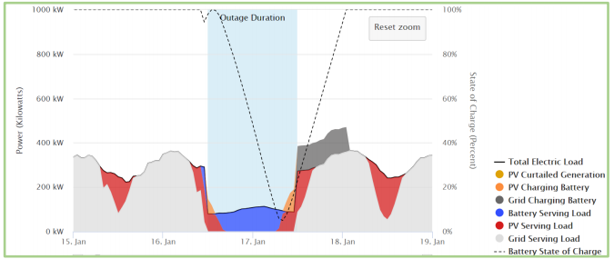

**4 Conclusion**

This report was checked multiple times by the temad advisors. they told us to correct some stuff. The corrections were made and they checked again if the report was well written. Also the addition of reference was recommended so the judges could see where the information was taken from. This was added and the advisors checked the report again. All the corrections needed were made so the report could be at its best.